Style Guidelines for Final Year Project Reports (Research and Development)

Title of the Project
Final Year Project Proposal
Session Fall 2026

BS in CS/SE/AI/CY



Department of CS/AI/SE/CY
Fast School of Computing
Fast National University, Karachi Campus
1st September 2026

Project Registration
Project ID (for office use)
Type of project |  |  | [ ] Traditional [ ] Industrial [ ] Continuing
Nature of project |  |  | [ ] Development [ ] Research & Development [ ] Research
Sustainable Development Goals(SDGs) |  |  | [ ] Good Health and Well-Being [ ] Quality Education  [ ] Industry, Innovation, and Infrastructure [ ] Gender Equality  [ ] Decent Work and Economic Growth [ ] Climate Action
Area of specialization |  |  | [ ] Artificial Intelligence (AI) [ ] Data Science and Analytics  [ ] Internet of Things (IoT) [ ] Blockchain  [ ] Mobile App Development [ ] Web Development [ ] Cybersecurity  [ ] Game Development [ ] Natural Language Processing (NLP)  [ ] Other
Project Group Members
Sr.# | Reg. # | Student Name |  | CGPA | Email ID | Phone # | Signature
(i) | Group Leader
(ii)
(iii)
Declaration: FYP group members have cleared all prerequisite courses For FYP-I as per their degree requirements.

- Project Abstract (mandatory)
Under this heading, briefly describe the project to convey the abstract idea of the project using 250 to 300 words. The abstract should briefly describe the problem, proposed methodology, dataset, modules and expected contribution.

Introduction (mandatory)
Introduce the broader research area.
Discuss:
- What is the research domain?
- Why is it important?
- What is the current situation?
- Why is computational/AI/data-driven research relevant?

Problem Statement
Clearly define the problem that your research intends to solve.
The problem should not simply be:
"There is no software available for this problem."
Instead, a research problem should identify a knowledge, methodological, performance, or application gap.

Motivation (mandatory)
The motivation behind this project is to develop a practical solution for [problem/domain].
The project aims to:
- Reduce manual effort.
- Improve efficiency and accessibility.
- Automate repetitive tasks.
- Provide users with a simple and user-friendly interface.
- Improve the accuracy/reliability of the existing process.
- Provide centralized management of relevant information.

Aims and Objectives
The goal of the project and the main focused objectives of the project are discussed in this section.

Scope of the Project
Scope defines what needs to be achieved and the work that must be done to deliver a project. It includes specific project goals, deliverables, features, functions, tasks, deadlines, and ultimately costs.

Proposed Methodology
This section provides insight into what methodology you will employ in the development of the envisioned system. It is the systematic, theoretical analysis of the methods applied to your study. It can comprise step-by-step procedures, flowcharts, block diagrams or algorithms of the proposed system.

The system should provide the following functional and non-functional requirements.

System Architecture
The proposed system will follow a [three-tier/client-server/MVC/microservices] architecture. The major layers/components will include:
Presentation Layer – User interface
Application Layer – Business logic
Data Layer – Database and data management
The overall workflow will be:
User → User Interface → Application/Backend → Database → Results

Individual Tasks (mandatory if group project)
Please mention individual tasks in the table indicating individual tasks and justify the one-year effort of two or three students. The expected individual task list with the tentative plan is given below.
Team Member | Activity | Tentative Date
<Name 1> | Activity 01 | <Date>
 | Activity 02
 | Activity 03
 | Activity 04
 | <Activity n>

Gantt Chart (Mandatory)
As per individual tasks mentioned in the previous section, the Gantt chart shall graphically represent which tasks would be done in which duration, i.e., starting date, end date. What tasks shall be done in parallel, and what tasks shall be done in series? Duration of individual task. (View few samples from the internet before making your own to get ideas)

Tools and Technologies
Please describe the tools and technologies that the FYP group is planning to use in the project.

Expected Deliverables
Mention expected outcomes or deliverables

References (if needed)
You must provide references (IEEE style) when appropriate to justify your study.
Use IEEE referencing style available in Microsoft word as shown in Fig. 1.
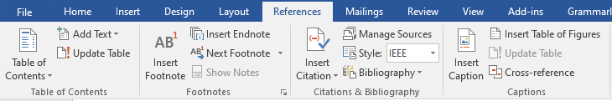
Figure 1. Word references tab.

General Guidelines
Before starting write up, first, confirm that the correct template has the correct paper size. This FYP proposal template has been tailored for output on the A4 paper size. Specify paper width according to dimensions shown in Figure 2.
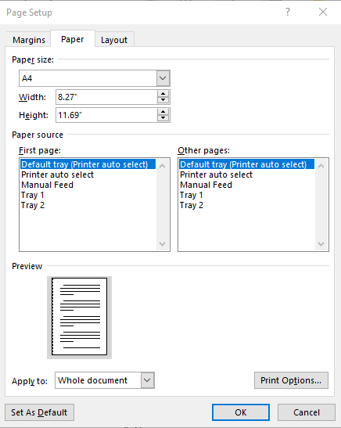
Figure 2. Paper size settings.
Ensure page margins are according to the margin values shown in Fig. 2.
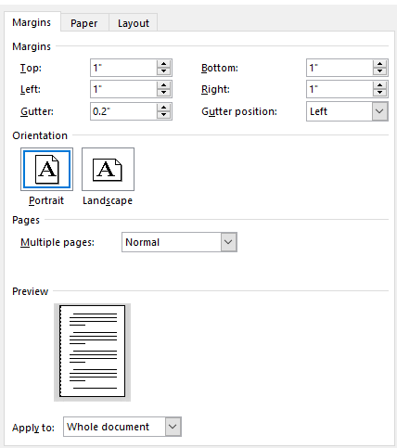
Figure 3. Template page margins.

Template Heading (Heading-1)
Each section should start with heading font size 16, bold, and font face “Times New Roman”. First, outline the proposal in different sections and try to include relevant heading. If it is required to split the section into sub-headings, should use a font size of 13, bold, and font face “Times New Roman.

Selecting a Sub Heading (Heading-2)
Describe FYP in detail problem background, problem complexity, and proposed solution.

Selecting Sub Sub Heading (Heading-3)
Follow the numbering style for the sub-sub-section under the main section. In order to write the third level of subheading, use font size 12 and font face italic “Times New Roman.”

Body Text
All the body text should be in font size 12 and single line spacing. Moreover, ensure that the complete document must use only font-face “Times New Roman”.

Figures and Tables
Use the following instructions to create tables and figures. All the figures and tables must be cross-referred in the text. For example, the figure is inserted in the introduction section in this document figure and can refer to the paper size, and margins see Fig. 1. In the same way, all tables should be cross-referred in the text.

Figures and Tables
Figure captions should be below the figures; table heads should appear above the tables. Insert figures and tables after they are cited in the text. Use the abbreviation “Fig. 1”, even at the beginning of a sentence.
- Table Type Styles
Table Head | Table Column Head
 | Table column subhead | Subhead | Subhead
copy | More table copy
- Example of a figure caption. (figure caption)
Figure Labels: Use 11 point Times New Roman for Figure labels. Use words rather than symbols or abbreviations when writing Figure axis labels to avoid confusing the reader.

